**CMR Institute of Technology**

**Kandlakoya Village, Medchal Rd, Hyderabad, Telangana 501401**

**Institute Innovation cell**

**Developing Online Repository of Ideas Developed and Wayforward plan**

**Team Name: Agri Team**

Members:

1. 20R01A0467, DAMMAREDDYGARI SAI SUMANTH REDDY

2. 20R01A0480, KAMMARI SAIKRISHNA SOWMITH

3. 20R01A04A2, PULLATIKURTHI SAI KUMAR

Idea Title: Arduino based Automatic Water Sprinkler

Problem Statement:

Dehydration of plants due to insufficient water supply

# **OVERVIEW**

In this system, soil moisture sensors sense the moisture level of the soil. If soil gets dry then the sensor senses low moisture level and automatically switches on the water pump to supply water to the plant.

# **GOALS/Objectives**

1. To attain, automatic irrigation system in the agriculture sector.
2. To reduce loss of water .
3. To water plants at regular intervals of time.

# **SPECIFICATIONS**

# This is a DIY Automatic water sprinkler completely from scratch. With this we can water our plants at regular intervals of time without any human interaction. At regular intervals of time supply has to be checked. Arduino UNO is used for automation.

# **MILESTONES**

## **Ideation/Data collection**

Automatic water supply to the plants by using moisture sensor and arduino.

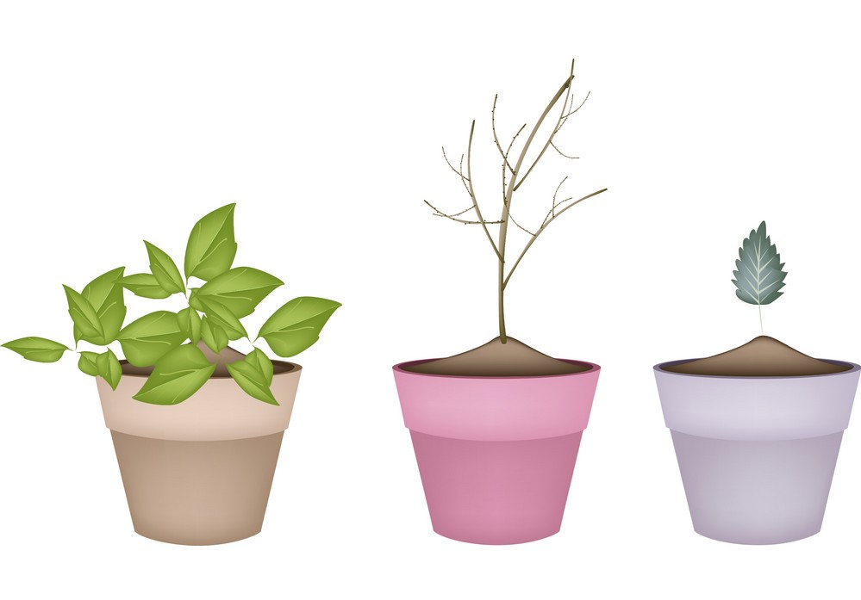

Fig 1: Problem scenario



Fig: Data collection

## **Model Building**

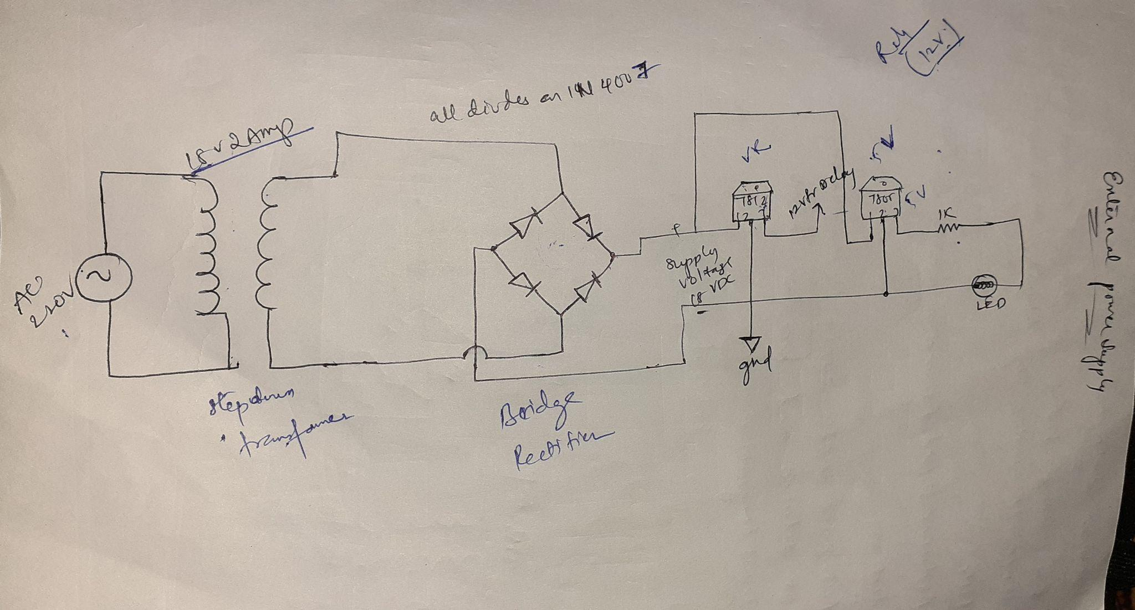

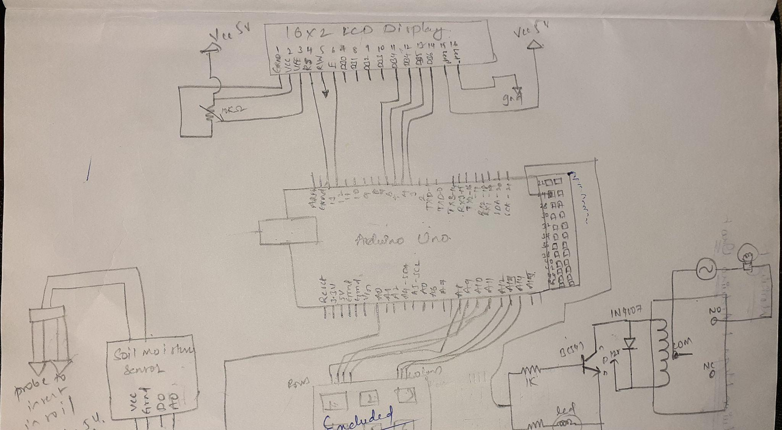

Fig 2 Model or blueprint: Arduino based automatic water sprinkler

## **Components/Tools Understanding and usage**

1. Arduino UNO: Arduino UNO is a low-cost, flexible, and easy-to-use programmable open-source microcontroller board that can be integrated into a variety of electronic projects. It is the control unit of this project.

2.Soil moisture sensor: The Soil Moisture Sensor is used to measure the volumetric water content of soil. The Soil Moisture Sensor uses capacitance to measure the water content of soil.

3. 1N4007 diodes: The 1N4007 is a used general-purpose diode. It is normally constructed to be used as a rectifier in the power supply section of electronic devices to convert AC voltage to DC voltage with other filter capacitors.

1. General purpose npn transistor: Transistors are commonly used in digital circuits as electronic switches which can be either in an "on" or "off" state.
2. Male and female jumper wires
3. 5V relay
4. Power supply
5. Voltage regulators 7803 and 7812
6. LED red lights
7. Bread board
8. Capacitors
9. Resistors

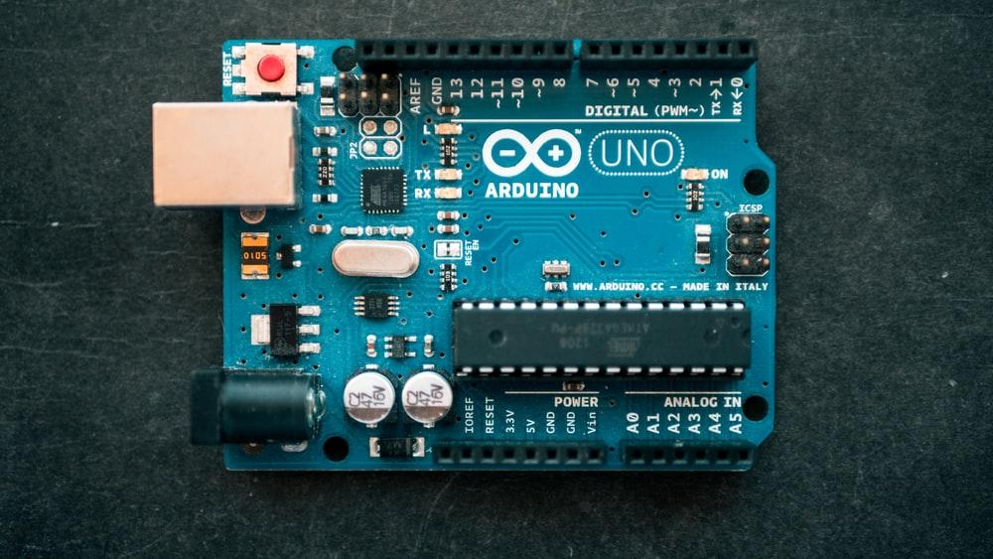

Fig 3.1: Arduino UNO

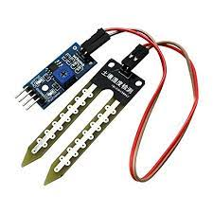

Fig 3.2 : Soil Moisture sensor

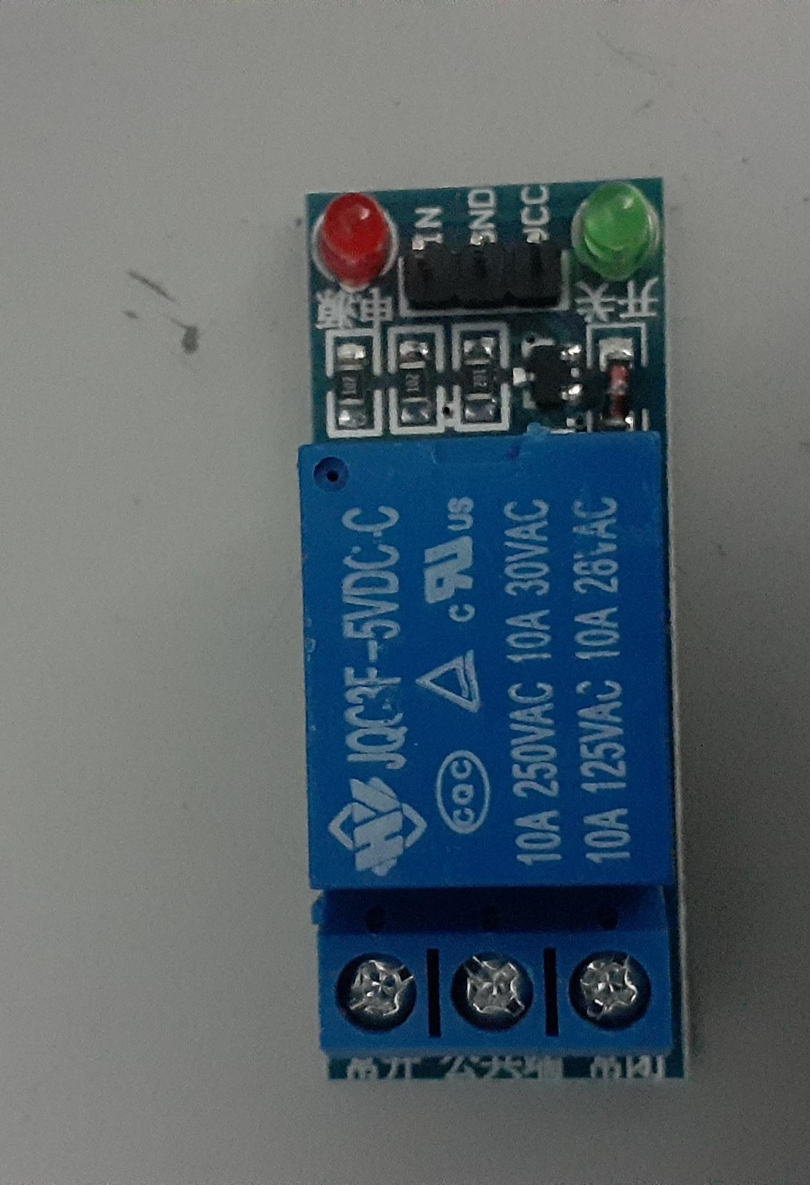

Fig 3.3: 5V relay

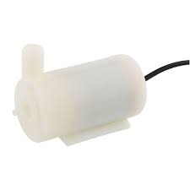

Fig 3.4: Mini water pump

## **Prototyping**

Lorem ipsum dolor sit amet, consectetuer adipiscing elit, sed diam nonummy nibh euismod tincidunt ut laoreet dolore magna aliquam erat volutpat

Fig 4 Prototype: _____________________

## **Testing**

Fig 5 Testing/Users feedback

Lorem ipsum dolor sit amet, consectetuer adipiscing elit, sed diam nonummy nibh euismod tincidunt ut laoreet dolore magna aliquam erat volutpat